Sport Weiß GmbH & Co KG - Haupstr 3 - 89364 Rettenbach - Tel.: 08222/4132460 - tanja@sporttanjaweiss.de - www.sporttanjaweiss.de

Pos : 1
Diesel D-ROISIN L.34 PANTALONI 00STRU069EF; 4 St., Preis: 25,90 €
1x26/34, 1x28/34, 1x29/34, 1x30/34

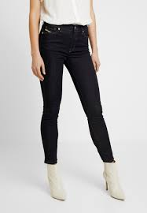

Pos : 2
Diesel D-FAYZA L.30 PANTALONI 00SV1S009EU; 5 St., Preis: 25,90 €
1x26/30, 2x29/30, 1x31/30, 1x32/30

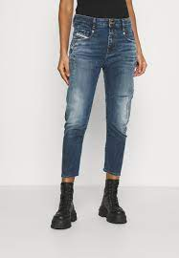

Pos : 3
Diesel BABHILA-ZIP L.30 PANTALON A00385009EZ; 5 St., Preis: 24,90 €
1x26/30, 1x27/30, 1x28/30, 1x29/30, 1x31/30

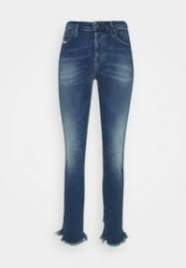

Pos : 4
Diesel D-AKEMI L.34 PANTALONI A01007009KE; 4 St., Preis: 29,50 €
Gr 26/34

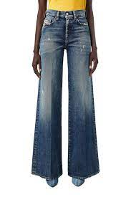

Pos : 5
Diesel D-REGGY-SP4 L.32 PANTALON A01181009LC; 2 St., Preis: 29,50 €
Gr 26/32

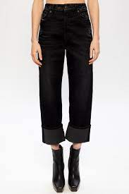

Pos : 6
Diesel D-SLANDY-BT L.32 PANTALON A01441069QN; 5 St., Preis: 29,50 €
1x24/32, 1x25/32, 1x26/32, 1x28/32, 1x30/32

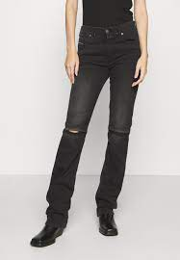

Pos : 7
Diesel D-SPRITZZ-SP1 L.34 PANTAL A02093009RN; 4 St., Preis: 29,50 €
26/34

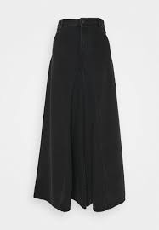

Pos : 8
Diesel BELTHER-R L.30 PANTALONI 00SWI0R06C7; 21 St., Preis: 24,90 €
2x28/30, 3x29/30, 7x30/30, 2x31/30, 6x32/30, 1x33/30

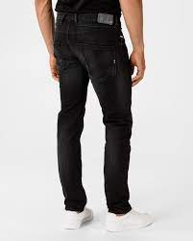

Pos : 9
Diesel SLANDY-LOW L.34 PANTALONI 00SGSR069TR; 5 St., Preis: 29,50 €
2x25/34, 2x26/34, 1x31/34

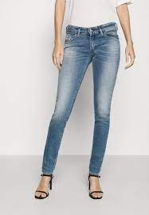

Pos : 10
Diesel ARYEL L.32 PANTALONI 00SHG7089AL; 10 St., Preis: 29,50 €
3x24/32, 2x25/32, 5x28/34

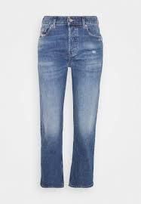

Pos : 11
Diesel D-EISELLE L.32 PANTALONI 00SMNI069DY; 4 St., Preis: 29,50 €
1x25/32, 2x29/43, 1x30/32

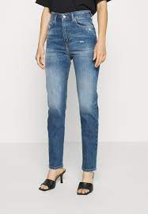

Pos : 12
Diesel BUSTER L.30 PANTALONI 00SDHAR58K8; 32 St., Preis: 24,90 €
5x28/30, 12x29/30, 6x30/30, 8x31/30, 1x32/30

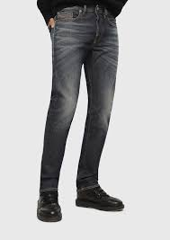

Pos : 13
Diesel SLANDY-LOW L.32 PANTALONI 00SGSQ083AN; 12 St., Preis: 24,90 €
4x26/32, 4x27/32, 3x30/32, 1x31/32

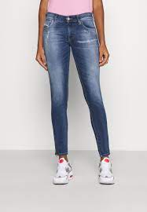

Pos : 14
Diesel MHARKY L.30 PANTALONI 00SH3P084ZM; 19 St., Preis: 24,90 €
7x28/30, 12x29/30

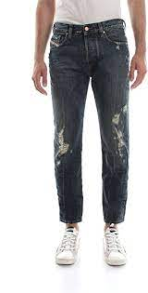

Pos : 15
Diesel SLEENKER-X L.32 PANTALONI 00SWJF069FY; 9 St., Preis: 24,90 €
5x27/32, 3x28/32, 1x30/32

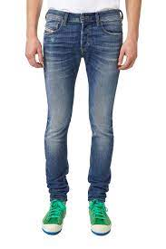

Pos : 16
Diesel BABHILA-T-SP2 L.32 PANTAL A02572009VG; 5 St., Preis: 26,90 €
3x26/32, 2x27/32

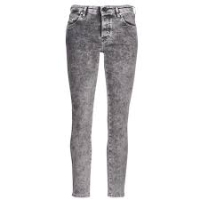

Pos : 17
Diesel SLANDY L.32 PANTALONI 00SXJN084ZA; 6 St., Preis: 25,90 €
2x24/32, 3x25/32, 1x26/32

Pos : 18
Diesel D-ROISIN-HIGH L.32 PANTAL A00007069MZ; 6 St., Preis: 29,50 €
Gr 26/32

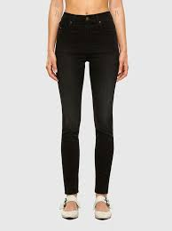

Pos : 19
Diesel D-JEVEL L.34 PANTALONI A00070009PK; 5 St., Preis: 24,90 €
2x25/34, 2x26/34, 1x27/34

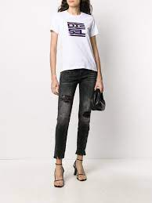

Pos : 20
Diesel WIDEE-X L.34 PANTALONI A00369009EU; 2 St., Preis: 25,90 €
1x26/34, 1x31/34

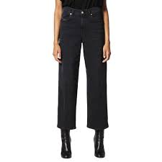

Pos : 21
Diesel ZATINY-X L.32 PANTALONI A00896069TN; 3 St., Preis: 24,90 €
1x29/32, 1x31/32, 1x40/32

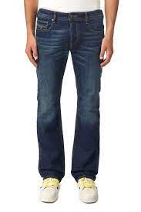

Pos : 22
Diesel D-JOY-T-SP L.30 PANTALONI A01072009KY; 6 St., Preis: 25,90 €
2x24/30, 2x25/30, 1x28/30, 1x32/30

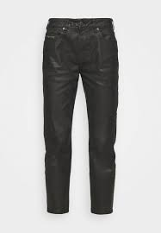

Pos : 23
Diesel D-EBBEY-KY L.30 PANTALONI A011730870G; 4 St., Preis: 29,50 €
3x28/30, 1x29/30

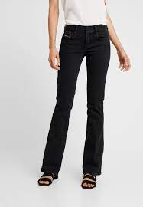

Pos : 24
Diesel D-REGGY-GO L.30 PANTALONI A01716009QJ; 5 St., Preis: 29,50 €
3x23/30, 2x25/30

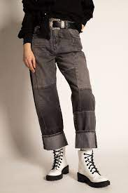

Pos : 25
Diesel D-FRANKY-SP1 L.34 PANTALO A02021009MC; 3 St., Preis: 29,50 €
1x28/34, 1x29/34, 1x38/34

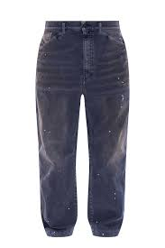

Pos : 26
Diesel D-JOY-SP2 L.32 PANTALONI A02511009UY; 6 St., Preis: 29,50 €
1x26/32,3x28/32, 2x29/32

