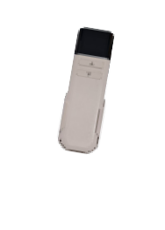
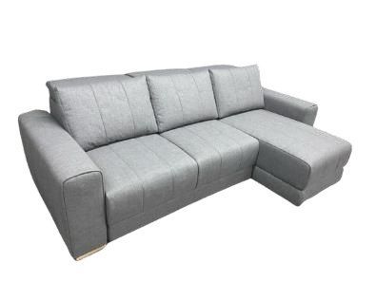
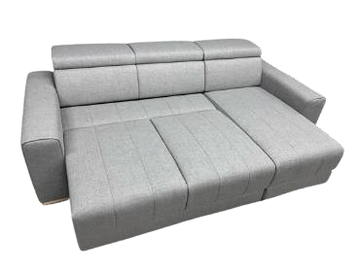
 | Porto
2 PLACES (CANAPE ELECTRIQUE) | Cat B | Cat C | Cat D | Vol. m³ | Peso kg | Nr. Colli
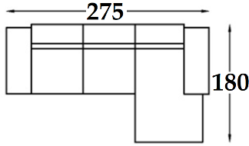 | € 559 | € 588 | € 646 | 2.50 | 130 | 3

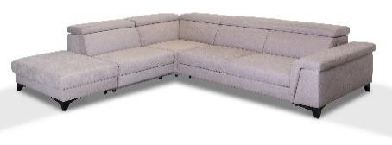 | Sento |  |  | 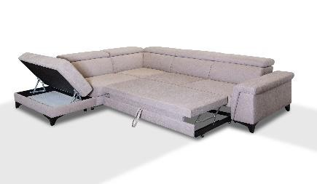
2 PLACES | Cat B | Cat C | Cat D | Vol. m³ | Peso kg | Nr. Colli
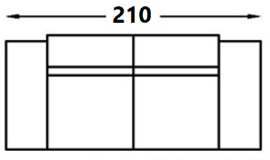 | € 338 | € 356 | € 391 | 1.10 | 70 | 2
SENTO II | Cat B | Cat C | Cat D | Vol. m³ | Peso kg | Nr. Colli
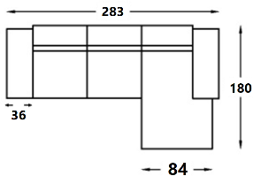 | € 503 | € 529 | € 582 | 2.20 | 100 | 4
SENTO III | Cat B | Cat C | Cat D | Vol. m³ | Peso kg | Nr. Colli
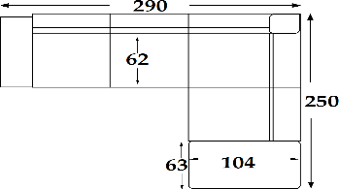 | € 637 | € 668 | € 736 | 2.80 | 130 | 5

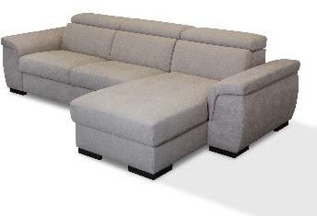 | Flori |  |  | 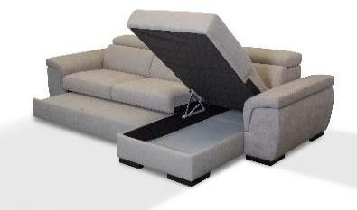
2 PLACES | Cat B | Cat C | Cat D | Vol. m³ | Peso kg | Nr. Colli
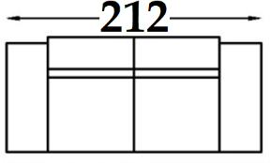 | € 308 | € 323 | € 356 | 1.15 | 70 | 2
FLORI II | Cat B | Cat C | Cat D | Vol. m³ | Peso kg | Nr. Colli
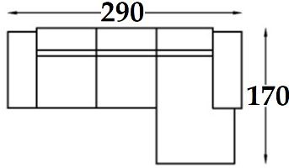 | € 477 | € 501 | € 551 | 2.30 | 100 | 4
FLORI III | Cat B | Cat C | Cat D | Vol. m³ | Peso kg | Nr. Colli
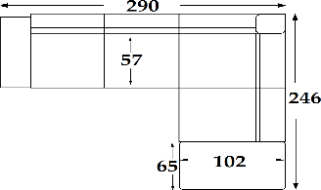 | € 596 | € 626 | € 688 | 3.00 | 130 | 5
FLORI II XL | Cat B | Cat C | Cat D | Vol. m³ | Peso kg | Nr. Colli
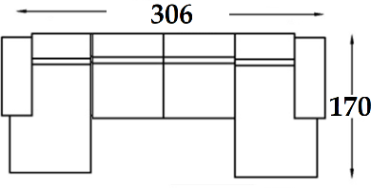 | € 596 | € 626 | € 688 | 2.90 | 130 | 5
FLORI III XL | Cat B | Cat C | Cat D | Vol. m³ | Peso kg | Nr. Colli
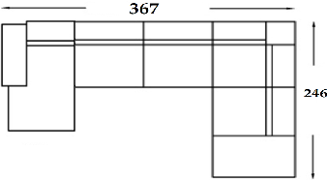 | € 750 | € 788 | € 868 | 3.40 | 150 | 6

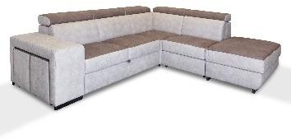 | lask |  |  | 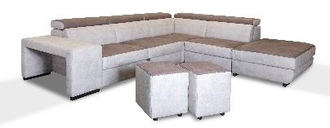
LASK | Cat B | Cat C | Cat D | Vol. m³ | Peso kg | Nr. Colli
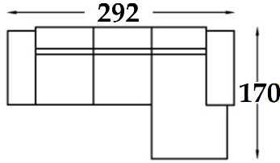 | € 479 | € 503 | € 554 | 2.30 | 120 | 4
LASK II | Cat B | Cat C | Cat D | Vol. m³ | Peso kg | Nr. Colli
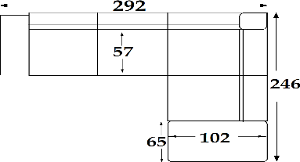 | € 621 | € 653 | € 718 | 3.00 | 140 | 5

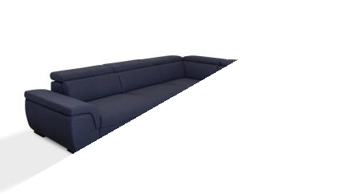 | Cali |  |  | 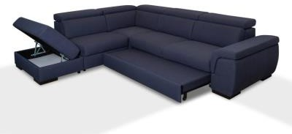
2 PLACES | Cat B | Cat C | Cat D | Vol. m³ | Peso kg | Nr. Colli
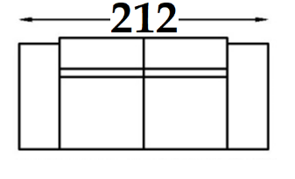 | € 292 | € 307 | € 337 | 1.15 | 70 | 2
CALI II | Cat B | Cat C | Cat D | Vol. m³ | Peso kg | Nr. Colli
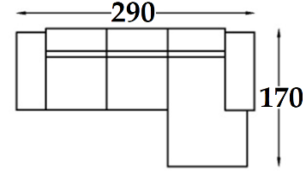 | € 462 | € 485 | € 533 | 2.30 | 100 | 4
CALI III | Cat B | Cat C | Cat D | Vol. m³ | Peso kg | Nr. Colli
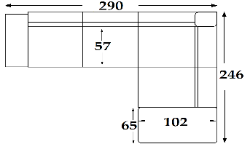 | € 578 | € 604 | € 664 | 3.00 | 130 | 5
CALI II XL | Cat B | Cat C | Cat D | Vol. m³ | Peso kg | Nr. Colli
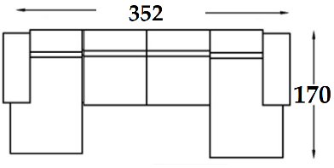 | € 576 | € 604 | € 664 | 2.90 | 130 | 5
CALI III XL | Cat B | Cat C | Cat D | Vol. m³ | Peso kg | Nr. Colli
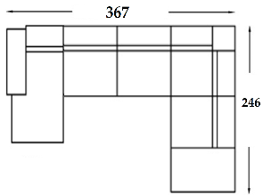 | € 698 | € 733 | € 803 | 3.40 | 150 | 6

 | CAPRI |  |  | 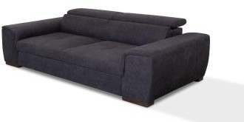
2 PLACES | Cat B | Cat C | Cat D | Vol. m³ | Peso kg | Nr. Colli
 | € 266 | € 280 | € 308 | 1.10 | 70 | 2
CAPRI II | Cat B | Cat C | Cat D | Vol. m³ | Peso kg | Nr. Colli
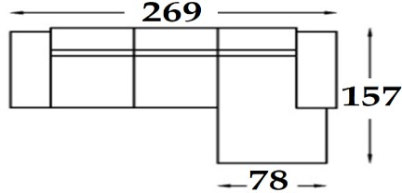 | € 390 | € 410 | € 451 | 2.50 | 110 | 4
CAPRI III | Cat B | Cat C | Cat D | Vol. m³ | Peso kg | Nr. Colli
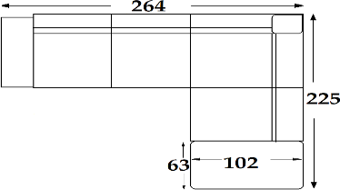 | € 487 | € 507 | € 557 | 3.10 | 145 | 5

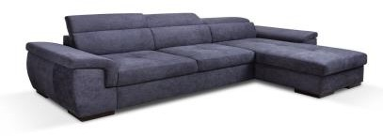 | Arizona |  |  | 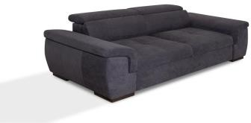
2 PLACES | Cat B | Cat C | Cat D | Vol. m³ | Peso kg | Nr. Colli
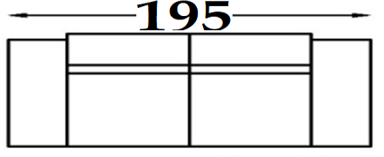 | € 266 | € 280 | € 308 | 1.10 | 70 | 2
ARIZONA II | Cat B | Cat C | Cat D | Vol. m³ | Peso kg | Nr. Colli
 | € 390 | € 410 | € 451 | 2.50 | 110 | 4
ARIZONA III | Cat B | Cat C | Cat D | Vol. m³ | Peso kg | Nr. Colli
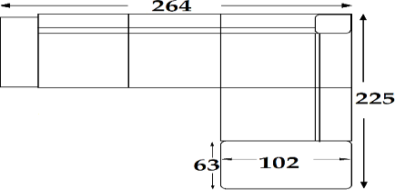 | € 487 | € 507 | € 557 | 3.10 | 145 | 5

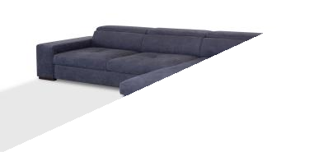 | ylan |  |  | 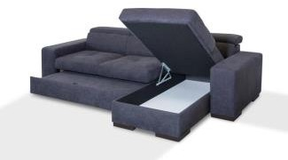
2 PLACES | Cat B | Cat C | Cat D | Vol. m³ | Peso kg | Nr. Colli
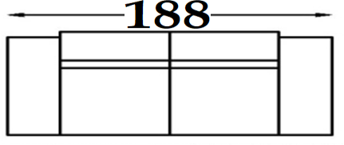 | € 246 | € 259 | € 286 | 1.10 | 70 | 2
YLAN II | Cat B | Cat C | Cat D | Vol. m³ | Peso kg | Nr. Colli
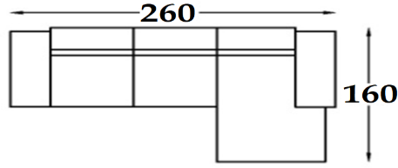 | € 359 | € 377 | € 416 | 2.50 | 110 | 4
YLAN III | Cat B | Cat C | Cat D | Vol. m³ | Peso kg | Nr. Colli
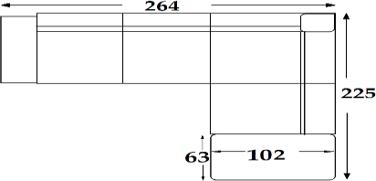 | € 462 | € 485 | € 533 | 3.10 | 145 | 5
YLAN II XL | Cat B | Cat C | Cat D | Vol. m³ | Peso kg | Nr. Colli
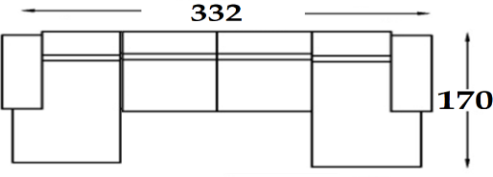 | € 493 | € 517 | € 568 | 2.90 | 120 | 5
YLAN III XL | Cat B | Cat C | Cat D | Vol. m³ | Peso kg | Nr. Colli
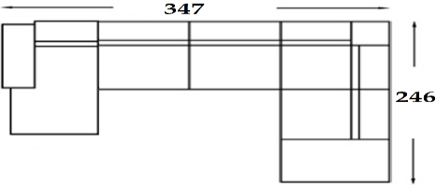 | € 630 | € 662 | € 728 | 3.30 | 140 | 6

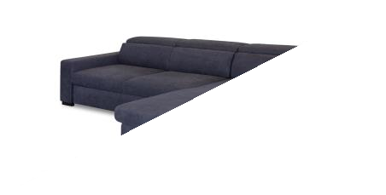 | eros |  |  | 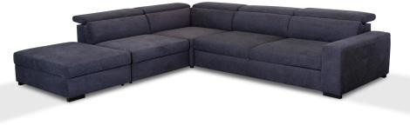
2 PLACES | Cat B | Cat C | Cat D | Vol. m³ | Peso kg | Nr. Colli
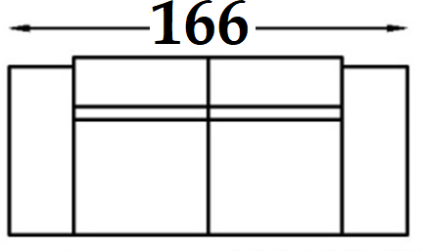 | € 257 | € 270 | € 297 | 1.10 | 70 | 2
EROS II | Cat B | Cat C | Cat D | Vol. m³ | Peso kg | Nr. Colli
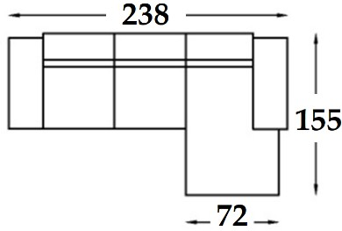 | € 333 | € 350 | € 385 | 1.70 | 100 | 3
EROS III | Cat B | Cat C | Cat D | Vol. m³ | Peso kg | Nr. Colli
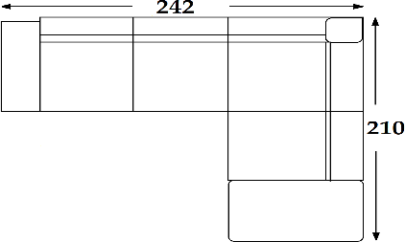 | € 470 | € 495 | € 545 | 2.20 | 130 | 5

 | Alfi
2 PLACES | Cat B | Cat C | Cat D | Vol. m³ | Peso kg | Nr. Colli
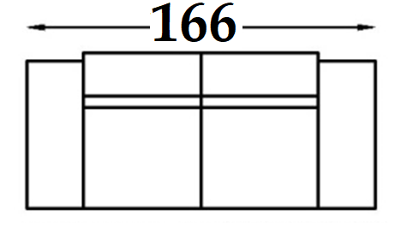 | € 225 | € 237 | € 260 | 1.10 | 70 | 2
ALFI II | Cat B | Cat C | Cat D | Vol. m³ | Peso kg | Nr. Colli
 | € 315 | € 331 | € 368 | 1.70 | 100 | 3
ALFI III | Cat B | Cat C | Cat D | Vol. m³ | Peso kg | Nr. Colli
 | € 451 | € 476 | € 523 | 2.20 | 130 | 5

 | Mala
2 PLACES | Cat B | Cat C | Cat D | Vol. m³ | Peso kg | Nr. Colli
 | € 204 | € 214 | € 236 | 1.10 | 70 | 2
MALA II | Cat B | Cat C | Cat D | Vol. m³ | Peso kg | Nr. Colli
 | € 282 | € 297 | € 326 | 1.70 | 100 | 3
MALA III | Cat B | Cat C | Cat D | Vol. m³ | Peso kg | Nr. Colli
 | € 406 | € 426 | € 468 | 2.20 | 130 | 5

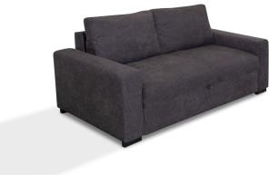 | Cret |  |  | 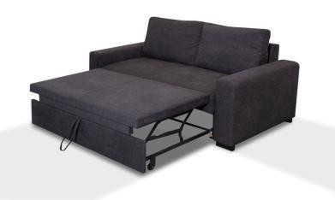
2 PLACES | Cat B | Cat C | Cat D | Vol. m³ | Peso kg | Nr. Colli
 | € 200 | € 210 | € 231 | 1.10 | 70 | 2
CRET II | Cat B | Cat C | Cat D | Vol. m³ | Peso kg | Nr. Colli
 | € 277 | € 291 | € 320 | 1.70 | 100 | 3
CRET III | Cat B | Cat C | Cat D | Vol. m³ | Peso kg | Nr. Colli
 | € 390 | € 410 | € 450 | 2.20 | 130 | 5
CRET II XL | Cat B | Cat C | Cat D | Vol. m³ | Peso kg | Nr. Colli
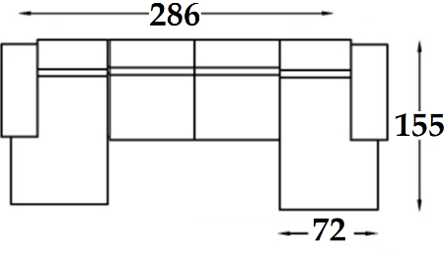 | € 390 | € 410 | € 450 | 2.30 | 150 | 4

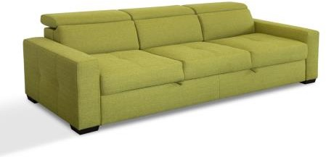 | Athena |  |  | 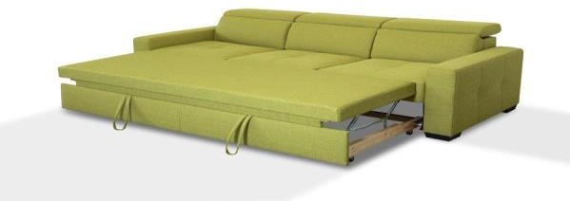
3 PLACES | Cat B | Cat C | Cat D | Vol. m³ | Peso kg | Nr. Colli
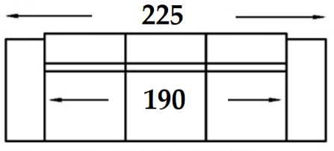 | € 324 | € 339 | € 378 | 1.10 | 70 | 2

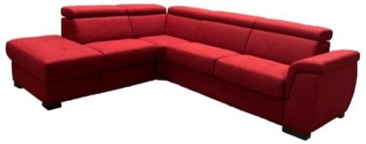 | Paestu
2 PLACES | Cat B | Cat C | Cat D | Vol. m³ | Peso kg | Nr. Colli
 | € 442 | € 462 | € 510 | 1.80 | 90 | 3
PAESTU II | Cat B | Cat C | Cat D | Vol. m³ | Peso kg | Nr. Colli
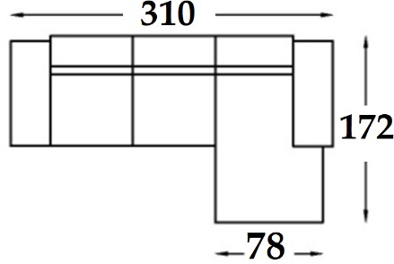 | € 637 | € 668 | € 735 | 2.80 | 110 | 4
PAESTU III | Cat B | Cat C | Cat D | Vol. m³ | Peso kg | Nr. Colli
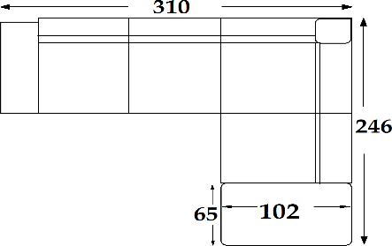 | € 771 | € 809 | € 891 | 3.30 | 140 | 6

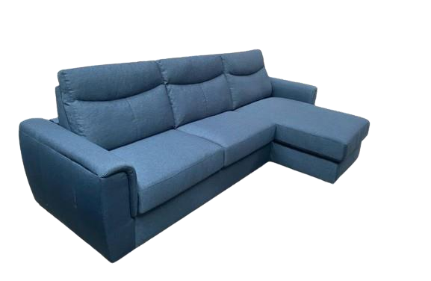
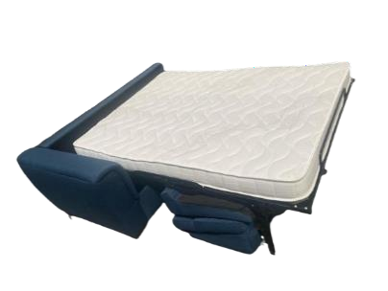
 | Meta
2 PLACES | Cat B | Cat C | Cat D | Vol. m³ | Peso kg | Nr. Colli
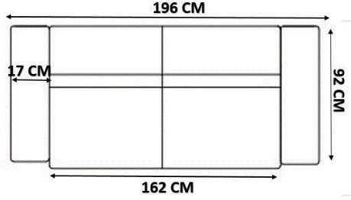 | € 418 | € 440 | € 480 | 1.55 | 90 | 3
META II | Cat B | Cat C | Cat D | Vol. m³ | Peso kg | Nr. Colli
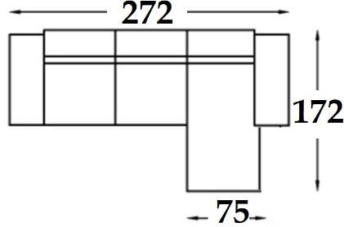 | € 579 | € 608 | € 669 | 2.70 | 110 | 4

 | Pari
2 PLACES | Cat B | Cat C | Cat D | Vol. m³ | Peso kg | Nr. Colli
 | € 418 | € 440 | € 480 | 1.55 | 90 | 3
PARI II | Cat B | Cat C | Cat D | Vol. m³ | Peso kg | Nr. Colli
 | € 579 | € 608 | € 669 | 2.70 | 110 | 4

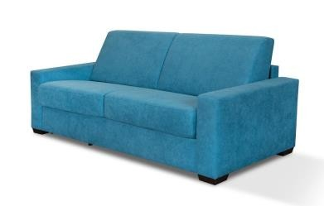 | Vulcan |  |  | 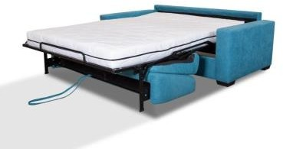
2 PLACES | Cat B | Cat C | Cat D | Vol. m³ | Peso kg | Nr. Colli
 | € 380 | € 399 | € 440 | 1.55 | 90 | 3

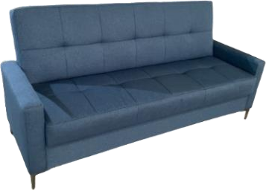 | Sida |  |  | 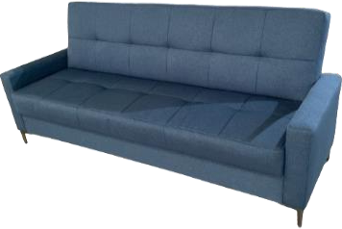
CLICK CLACK | Cat B | Cat C | Cat D | Vol. m³ | Peso kg | Nr. Colli
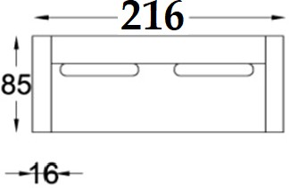 | € 150 | € 158 | € 174 | 0.69 | 67 | 1

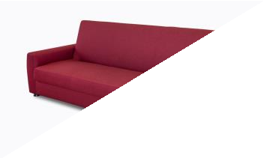 | Ristol |  |  | 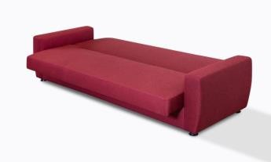
CLICK CLACK | Cat B | Cat C | Cat D | Vol. m³ | Peso kg | Nr. Colli
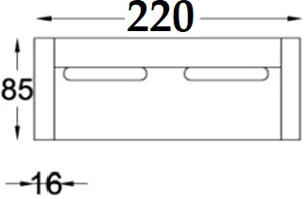 | € 133 | € 140 | € 154 | 0.70 | 67 | 2

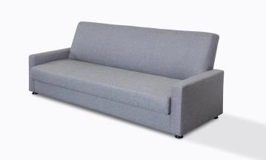 | Tall |  |  | 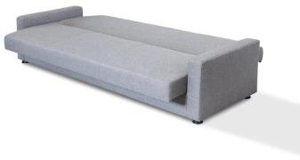
CLICK CLACK | Cat B | Cat C | Cat D | Vol. m³ | Peso kg | Nr. Colli
 | € 127 | € 134 | € 147 | 0.63 | 65 | 1

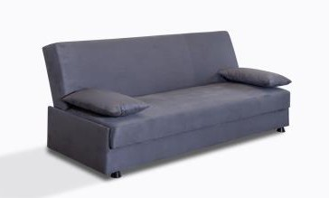 | Chia |  |  | 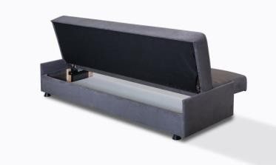
CLICK CLACK | Cat B | Cat C | Cat D | Vol. m³ | Peso kg | Nr. Colli
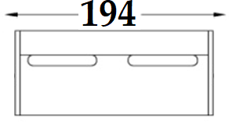 | € 117 | € 123 | € 136 | 0.60 | 60 | 1

 | Enna
 | Cat B | Cat C | Cat D | Vol. m³ | Peso kg | Nr. Colli
160x200 | € 266 | € 279 | € 308 | 0.64 | 105 | 3
140x200 | € 240 | € 253 | € 278 | 0.57 | 92 | 3
120x200 | € 215 | € 226 | € 248 | 0.50 | 81 | 3
90x200 | € 195 | € 205 | € 226 | 0.36 | 59 | 3

 | Riga
 | Cat B | Cat C | Cat D | Vol. m³ | Peso kg | Nr. Colli
160x200 | € 225 | € 236 | € 260 | 0.58 | 94 | 3
140x200 | € 203 | € 213 | € 235 | 0.52 | 84 | 3
120x200 | € 182 | € 210 | € 232 | 0.45 | 74 | 3
90x200 | € 163 | € 179 | € 207 | 0.33 | 54 | 3

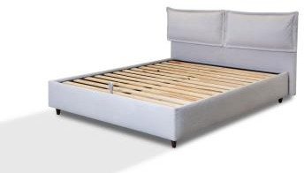 | Kiev |  |  | 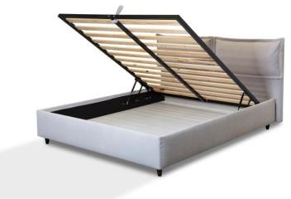
 | Cat B | Cat C | Cat D | Vol. m³ | Peso kg | Nr. Colli
160x200 | € 204 | € 214 | € 236 | 0.58 | 94 | 3
140x200 | € 184 | € 193 | € 213 | 0.52 | 84 | 3
120x200 | € 166 | € 174 | € 191 | 0.45 | 74 | 3
90x200 | € 149 | € 157 | € 172 | 0.33 | 54 | 3

